LAB TEST – 3
SCENARIO 1 :
Q1:
Scenario: In the Agriculture sector, a company faces a challenge related to data structures with ai.
Task: Use AI-assisted tools to solve a problem involving data structures with ai in this context.
Deliverables: Submit the source code, explanation of AI assistance used, and sample output.
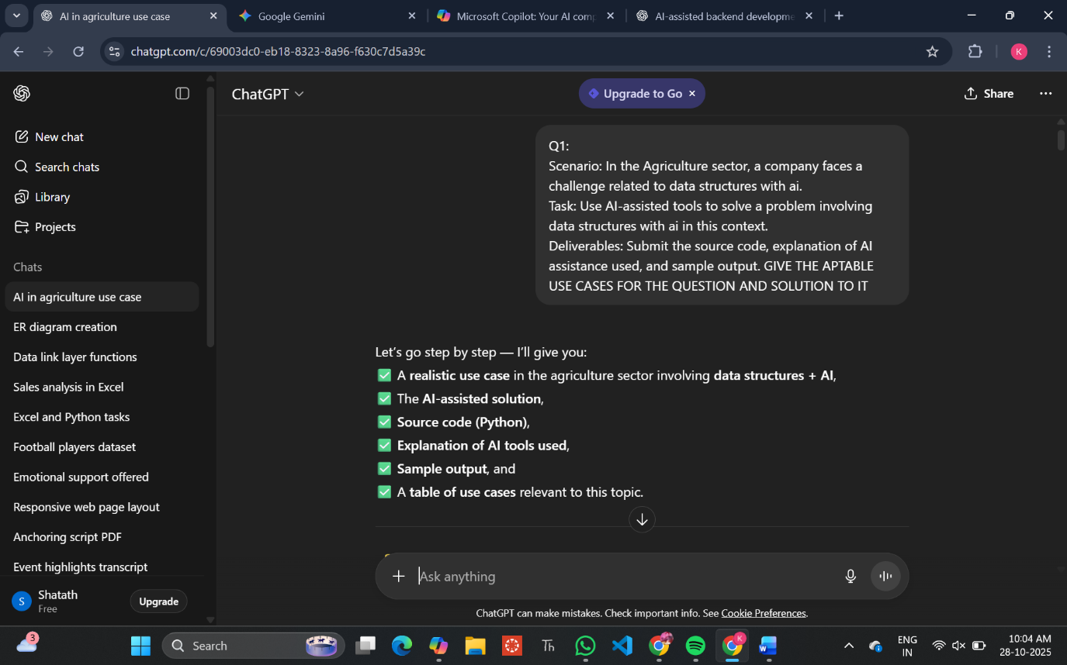

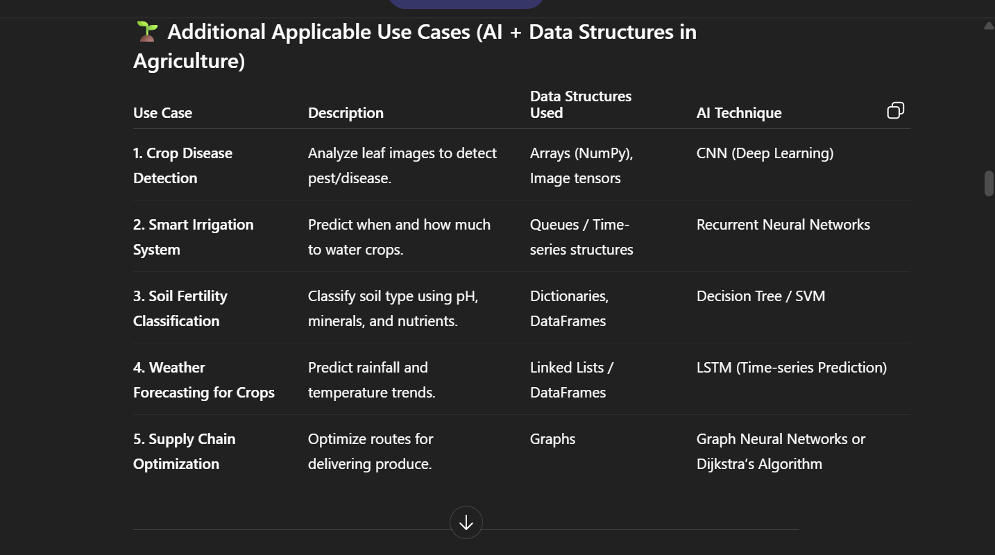

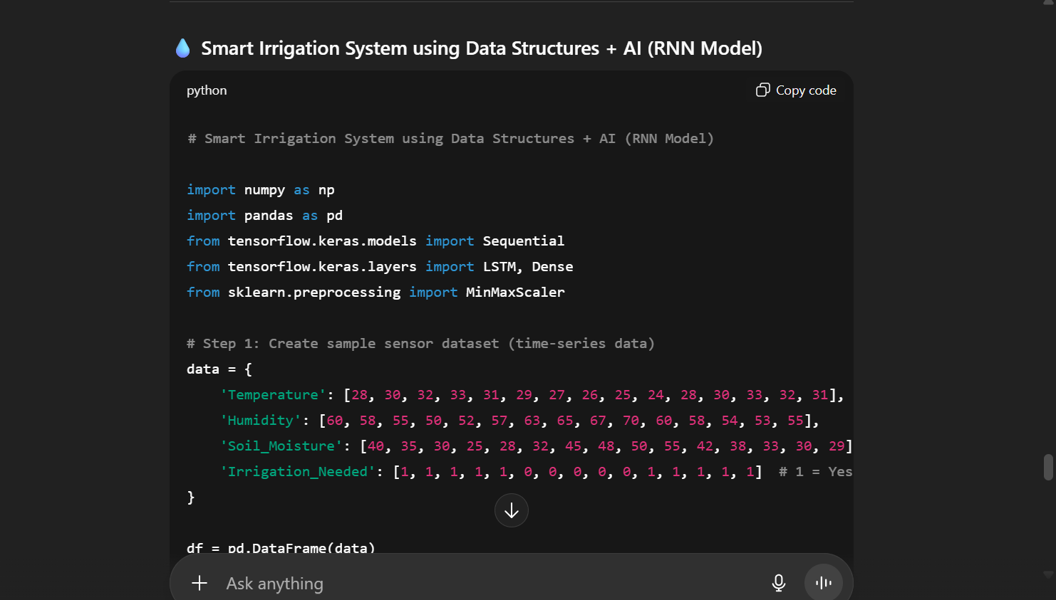

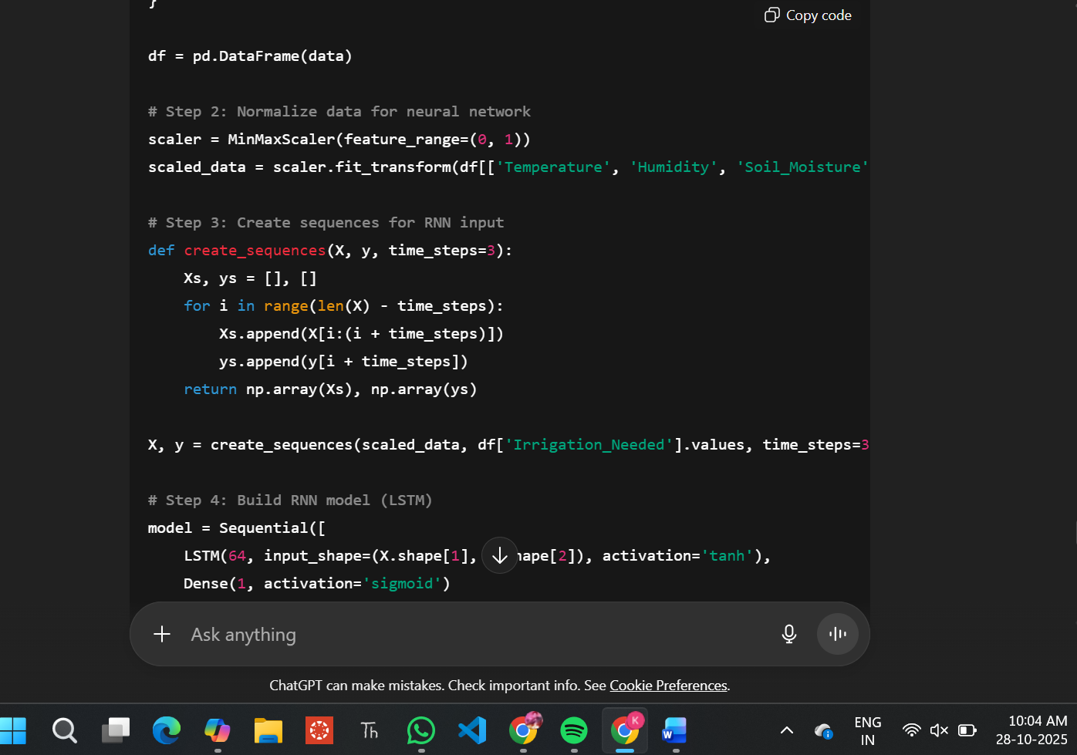

OUTPUT :
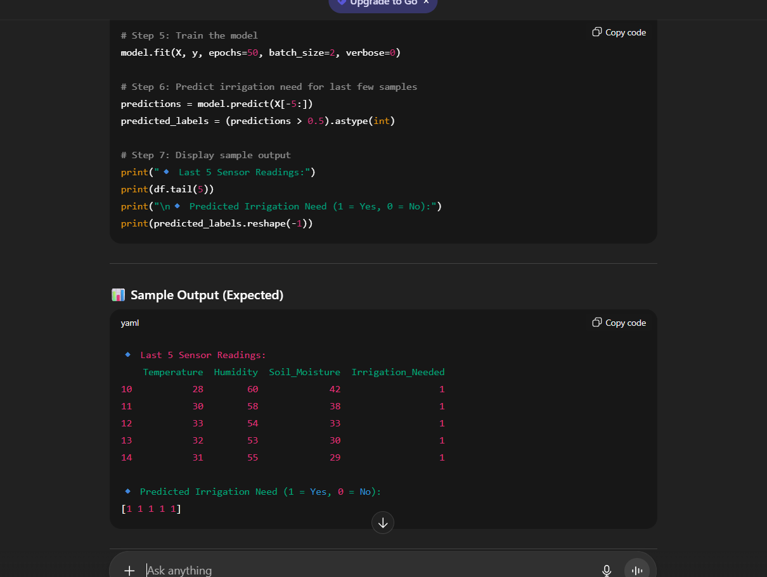
SCENARIO 2 :
Q2:
Scenario: In the Education sector, a company faces a challenge related to backend api development.
Task: Use AI-assisted tools to solve a problem involving backend api development in this context.
Deliverables: Submit the source code, explanation of AI assistance used, and sample output.

